Once you click ok on the image bellow the app will ask you to load some files.

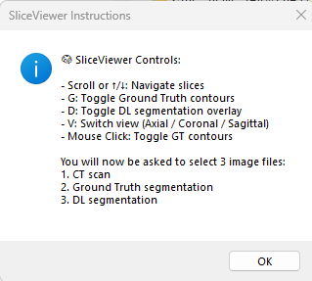

To load properly, navigate to : \\zkh\appdata\RTDicom\Projectline_modelling_lung_cancer\Users\Luis\Sharing\RobinWi\PatientsToReview

Select Patient : 6841834

To use the app correctly, follow this sequence:

**Load the Max Exp 50% CT scan**

File name: CT_MaxExp_0Ex_ct_.nii.gz

After selecting the file, **click Open**. A new pop-up window will appear to confirm the loading process.

**Load the Ground Truth (GT) segmentation**

File name: RTstructSelected_MaxExp__GTV.nii.gz

Again, **click Open** after selecting the file. A pop-up window will appear.

**Load the Deep Learning (DL) GTV contour**

File name: GTV50_DLContour.nii.gz

As before, **click Open** and wait for the pop-up window to confirm the load.

Once all files are successfully loaded, the app will display a view similar to the one shown below.

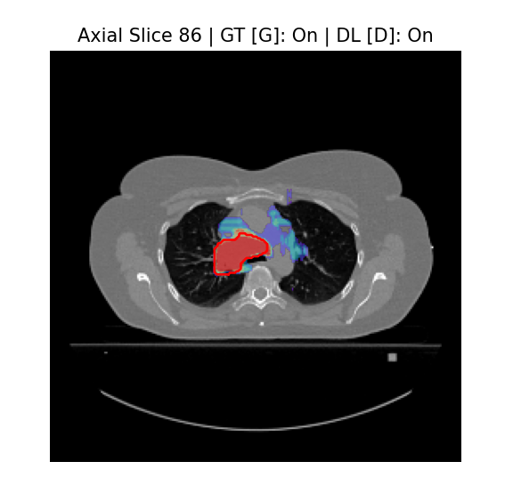

Figure caption : Axial view with DL on and GT on

You can scroll on to change the slices using the mouse

Next slice Scroll up / ↑

Previous slice Scroll down / ↓

Toggle GT contours G or mouse click

Toggle DL overlay D

Switch view (plane) V

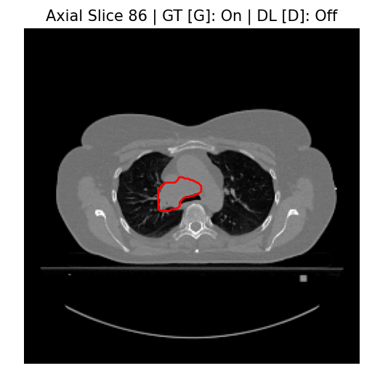

Figure caption: Axial view with DL off and GT on

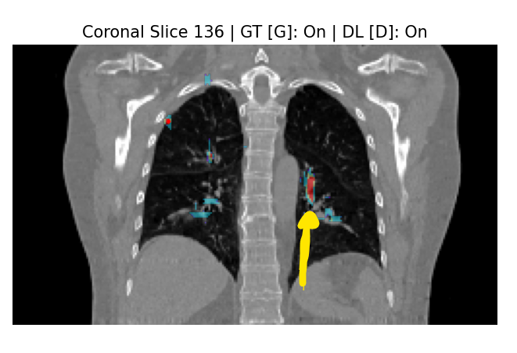

In the example above:

* Left image: DL is ON, GT is ON — but no GT is visible → this is a false positive.
* Right image: Shows the actual structure — possibly a vessel or another anatomical feature.

This patient serves as a demonstration of how the app is intended to be used.

In the coming days I intend to add a few patients that does require some attention, I expect to share with you the patient ID, view, slice and reason to check.

Let me know if this sounds a good way of working for you .